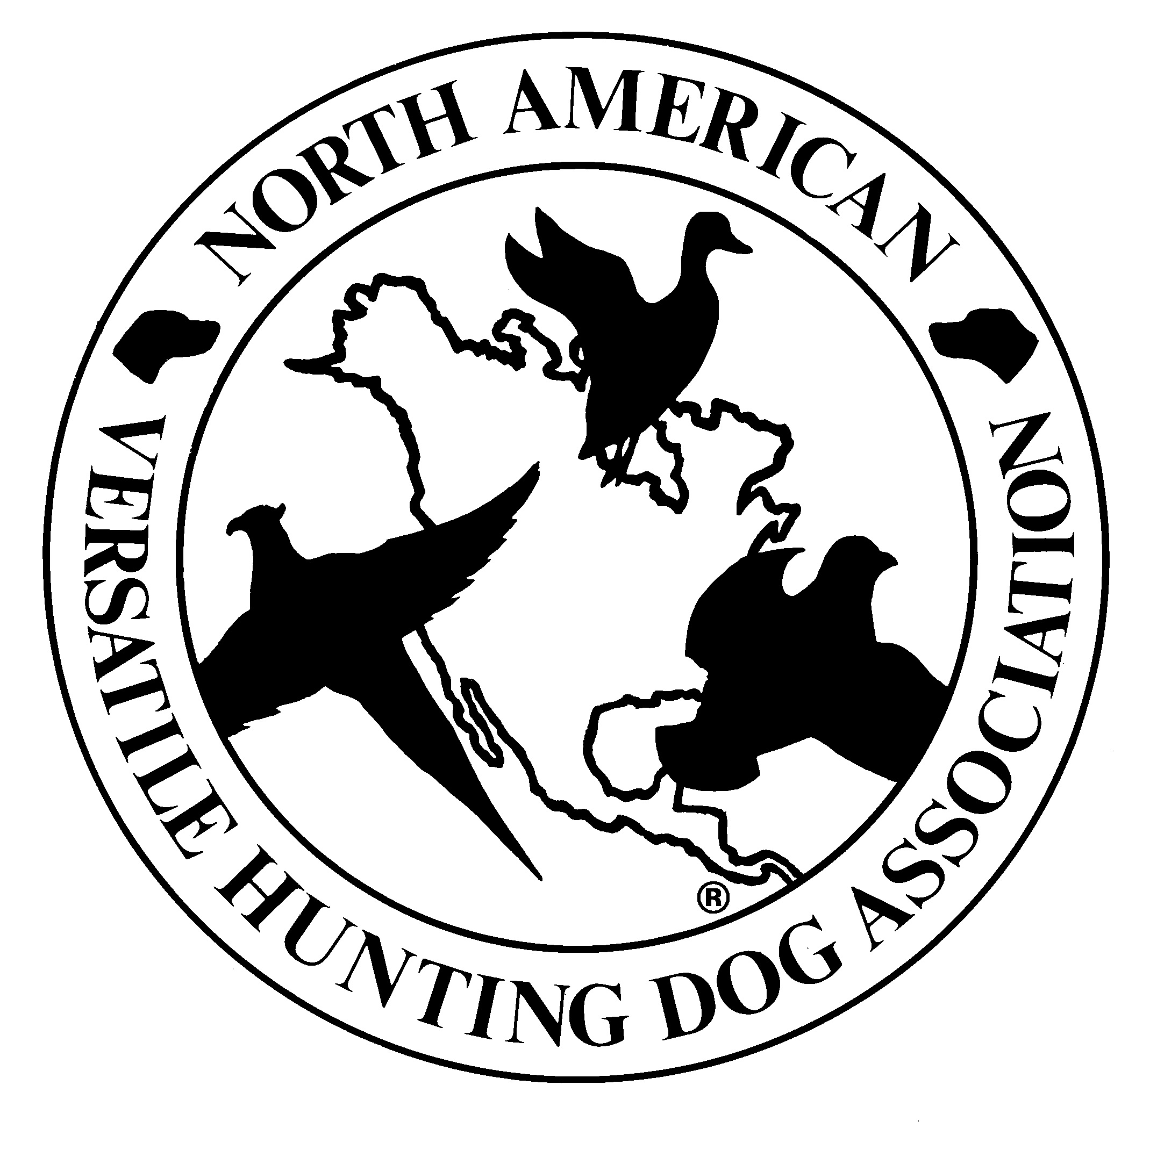
CAROLINAS CHAPTER, NAVHDA
AUTHORIZED GUNNER POLICY

01 September 2025

POLICY LETTER

From: Carolinas Chapter of NAVHDA Board of Directors
To: Carolinas Chapter Membership and non-members testing dogs at Carolinas Chapter of NAVHDA tests.

Subj: POLICY CONCERNING AUTHORIZED GUNNER REQUIREMENTS

1. Purpose. To establish a policy on the requirements of members in becoming an “AUTHORIZED GUNNER” at chapter tests.

2. Information. The current policy of Carolinas Chapter NAVHDA in reference to what is required to be considered an authorized gunner for chapter events are completion of a chapter approved wing shooting and safety clinic, recommendation by chapter gunner mentors, and approval from the executive committee.

a. Chapter approved wing shooting and safety clinic. For Members applying to be considered an “Authorized Gunner” they must attend a chapter Authorized wing shooting and safety clinic. This clinic must have been either offered by the chapter or approved by the chapter leadership.

b. Recommendation by Chapter Gunner Mentors. Members applying to be an “Authorized Gunner” for the chapter must be recommended by Chapter gunner Mentors to the executive committee after having attended a chapter authorized wing shooting and safety clinic.

c. Approval by Chapter Executive Committee. Members applying to be an “Authorized Gunner” for the chapter must be approved by the executive committee after having completed a Chapter authorized wing shooting and Safety clinic and have been recommended by a Chapter Gunner Mentor.

d. NAVHDA Invitational Gunners. Members applying to be an “Authorized Gunner” who have been approved to gun at the NAVHDA Invitational are automatically approved as an “Authorized Gunner” for the Chapter.

3. Scope. In order for members to be considered an “Authorized Gunner” for the chapter, the directives in the above paragraphs must be adhered to and will be verified by chapter leadership prior to Shooting as a gunner at any chapter test.

4. Removal from Authorized Gunner List. Chapter Leadership my remove anyone currently on the “Authorized Gunner” list in case of any safety violations, or in case an “Authorized Gunner” is not conducting their duties in accordance with Carolinas Chapter Navhda’s Gunner policies and best practices as outlined in the wing shooting and safety clinic as well as what they have learned in the mentorship program for the chapter.

Carolinas Chapter, NAVHDA
Board of Directors

